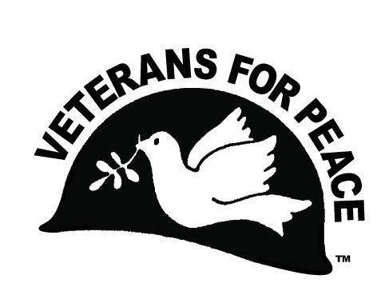
Peace Scholarships
Deadline: April 15, 2016
Application Form

You are eligible for this scholarship if both of these apply:
- You are a high school senior or college student at the time of application, AND
- You can provide evidence of leadership and/or personal initiative in activities or in an organization (including volunteer or paid work) relating to peace and social justice and/or conflict resolution AND
- You can demonstrate financial need

Applicant Information
Full Name: |  |  |  | Date:
Last |  |  | First | M.I.
Address:
Street Address Apartment/Unit #
City |  |  |  | State ZIP Code
Phone: |  |  | Email
Age: |  |  | Birthdate.: | Graduation Date:
(Parents or Legal Guardian)
Parent: Name |  |  |  | Contact:
Parent: Name: |  |  |  | Contact

I am applying to or attend: (Name of Institutions)

Application Essay
Provide a brief, typed essay on a separate piece of paper (no handwritten applications accepted). Be sure your name appears on it, and include:

Section 1: Discuss how this scholarship would financially impact your ability to enter college.

Section 2: A summary of your activities, organization work and/or awards relating to peace and social justice, education, and/or conflict resolution.

Section 3: Describe how you were more than simply a participant, i.e., how your leadership abilities and personal initiative made a difference for the activities or organizations you’ve been involved with.

Section 4: Describe your goals for the future.

Letters of Recommendation

  - Include at least two letters of recommendation from people (not members of your immediate family) who have personal knowledge of, and can describe, your academic achievements and/or leadership activities and personal initiative in working for peace & social justice, and/or conflict resolution.

  - Letters of recommendation must relate specifically to your leadership activities and personal initiative in working for peace and social justice, education and/or conflict resolution.

  - The letters must be included in the same envelope with this application. We regret we cannot accept email or faxed references, or letters mailed separately.

  - Be sure to START EARLY in requesting your letters of reference, so that you can receive them in time to mail everything to us in the same envelope by the April 1 deadline.

Affirmation of Eligibility & Signature

(initial here) I have visited the Gainesville Veterans web sitehttp://www.vfpgainesville.org/
and read about the eligibility requirements. I believe I am qualified to apply for this scholarship.

. .

Signature Date

Where did you learn about this scholarship?

.

Mail this application, postmarked by April 15, 2016 to:
Paul Ortiz,
Veterans for Peace Scholarship
2115 NW 7th LN
Gainesville, Florida 32603

The postmark deadline is April 15. No e-mail or fax applications

Scholarship recipients will be notified by April 22. Proof of actual college registration is required before we issue a check.

Only winners will be notified, and their names will be announced at the Gainesville Veterans for Peace Peace Poetry Awards Ceremony in May in Gainesville and will be posted on our web site. We are sorry we are unable to notify all applicants.

For questions: ortizprof@gmail.com

